Video No.: P 1202
Slide : 1 (Ring Ceremony)
Couple Name
Reema & Shivay

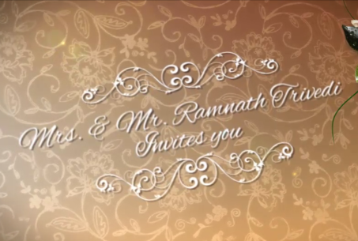 | Slide : 2  Mr. & Mrs. Ramnath Trivedi  Invites you

Slide : 3
In the celebration of Lifetime Love

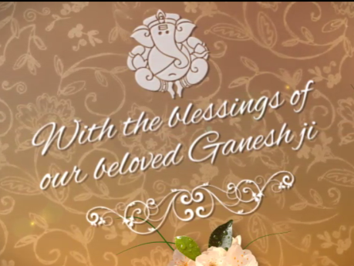 | Slide : 4  With the blessings of  our beloved Ganeshji

Slide : 5 (Couple Photograph & Name)
(High Resolution : Minimum 800 x 800 pixel)
Please rename your photograph with the name of Slide 4
Send your photograph by E-mail
Couple Name
Reema weds Shivay

Slide : 5 (Wedding Date & Time)
Date & Time
on 14th Feb, 2018, Sunday
11.00 am onwards

Slide : 6 (Function Detail)
Awaiting your gracious presence

Slide : 10 (Save the date)
Date :
Feb 14, 2018

Video Music :
Same As or If any choice please send me Youtub Link by mail and Mention in form also.
Link :
https://www.youtube.com/watch?v=nIhijSP3MBc

