Video No. P 1103
Slide : 1
The love Story of
Couple name
Piyush & Nishita

Slide : 2
Boy Meets Girl

Slide : 3
Visit Places

Slide : 4
In all hardships

Slide : 5
Fulfiling all the wishes

Slide : 6
Always there

Slide : 7
In all the occasions

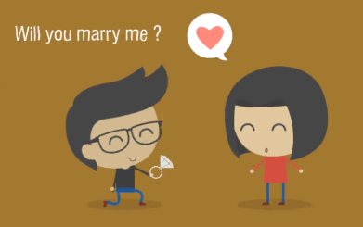 | Slide : 8  Will you marry me?

Slide : 9
Couple Name
Piyush & Nishita

Slide : 10
Are Getting
Married

Slide : 11
Save the Date
11.03.2018

Video Music :
Same As or If any choice please send me Youtub Link by mail and Mention in form also.
Link :

