Video No. P 1023
Slide : 1 (Couple Photograph & Name)
(High Resolution : Minimum 800 x 800 pixel)
Please rename your photograph with the name of Slide 3
Send your photograph by E-mail
Couple name
Diksha & Arnav

Slide : 2 (Bride Solo Photograph & Name)
(High Resolution : Minimum 800 x 800 pixel)
Please rename your photograph with the name of Slide 3
Send your photograph by E-mail
Bride name
Diksha

Slide : 3 (Groom Solo Photograph & Name)
(High Resolution : Minimum 800 x 800 pixel)
Please rename your photograph with the name of Slide 3
Send your photograph by E-mail
Groom name
Arnav

Slide : 4 (Function name)
Mehendi
Saturday, 7th Feb. 2018
4.00 pm onwards
At our Residence, 1032, Deal Street London E1 5AH UK.

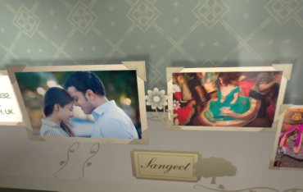 | Slide : 5 (Function name & Couple Photograph)  (High Resolution : Minimum 800 x 800 pixel)  Please rename your photograph with the name of Slide 3  Send your photograph by E-mail  Sangeet  Monday, 9th Feb. 2018  7.00 pm onwards  At our Residence, 1032, Deal Street London E1 5AH UK.

Slide : 6 (Function name & Couple Photograph)
(High Resolution : Minimum 800 x 800 pixel)
Please rename your photograph with the name of Slide 6
Send your photograph by E-mail
Wedding
Wednesday, 11th Feb. 2018
11.30 am onwards
At our Residence, 1032, Deal Street London E1 5AH UK.

Slide : 7 (Function name)
Reception
Wednesday, 11th Feb. 2018
7.00 pm onwards
At our Residence, 1032, Deal Street London E1 5AH UK.

Slide : 8 (couple Photograph & Save the Date)
(High Resolution : Minimum 800 x 800 pixel)
Please rename your photograph with the name of Slide 3
Send your photograph by E-mail

Save the Date :
11.2.2018

Video Music :
Same As or If any choice please send me Youtub Link by mail and Mention in form also.
Link :
Same As

